Install docker on EC2 and explore the docker commands (docker images, containers, volumes, network)

Launch EC2 instance with amazon linux

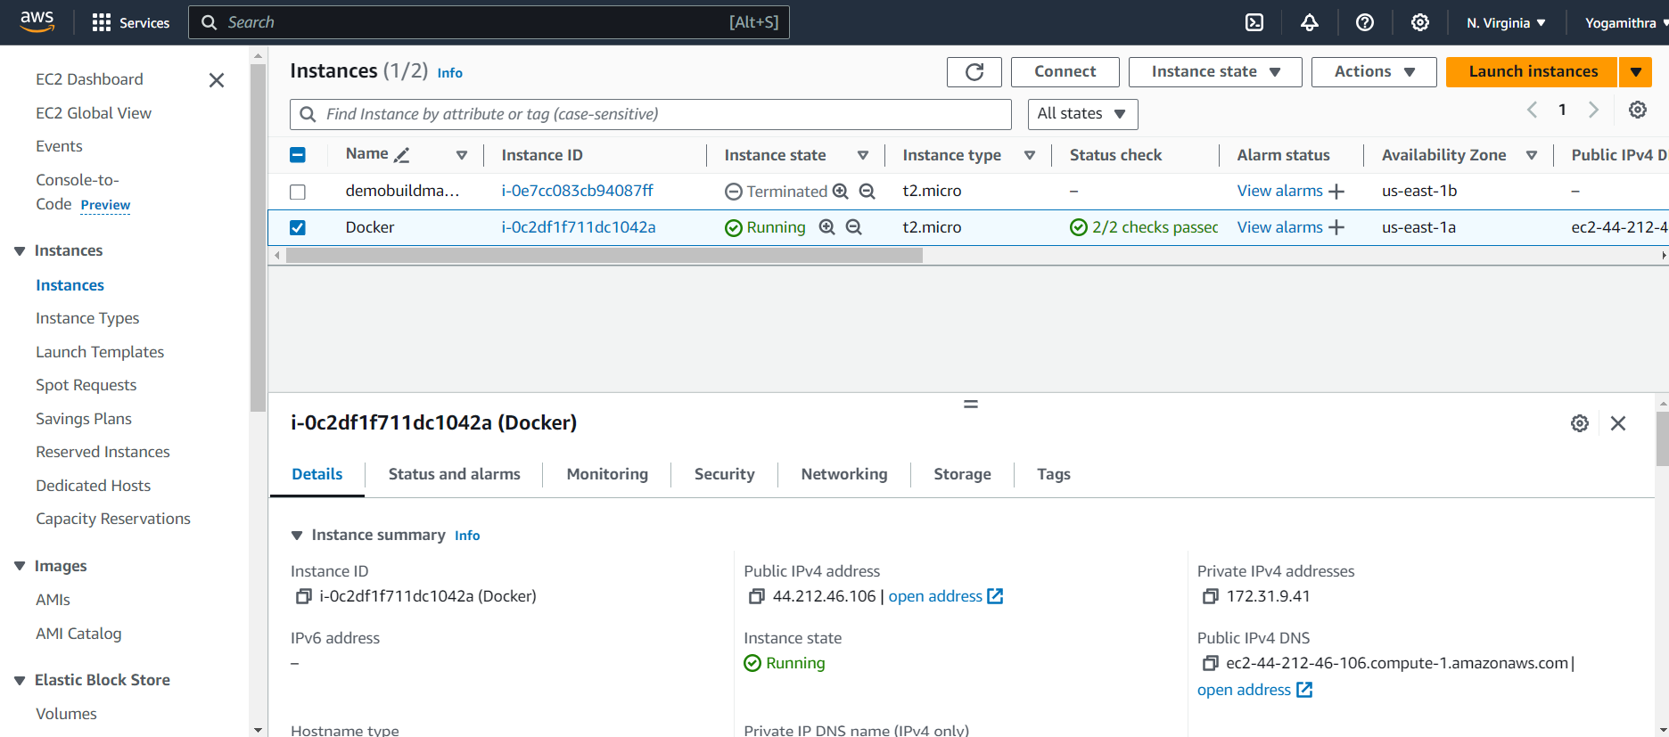

Connect via ssh client to the EC2 instance

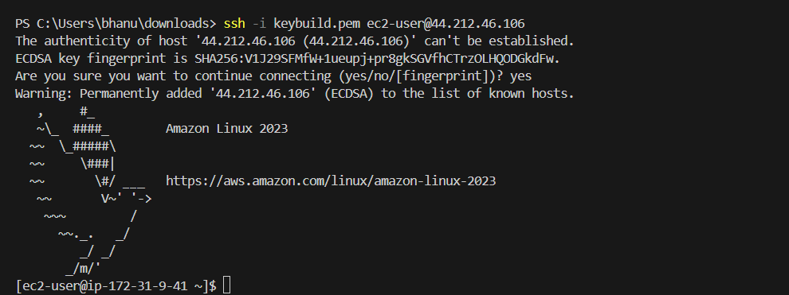

Install docker using the command

**sudo yum install docker -y**

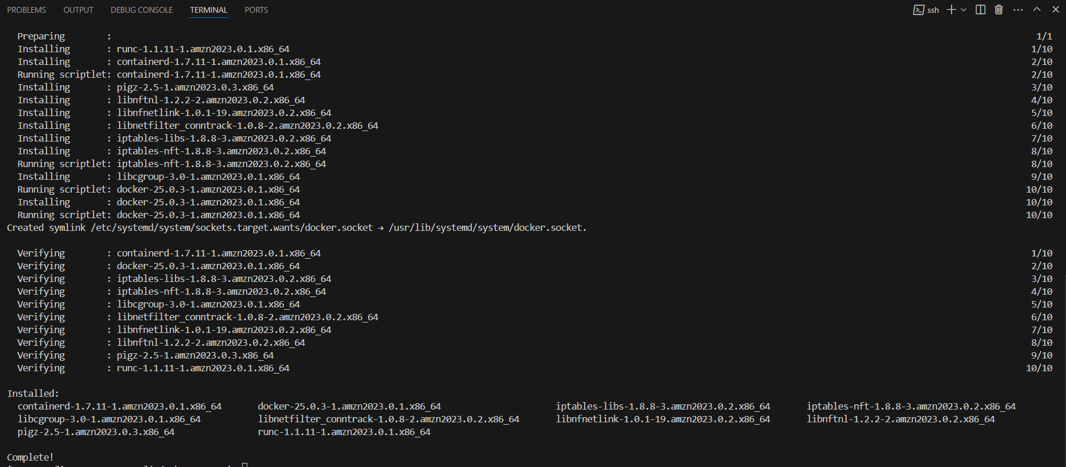

Check the version of the docker installed

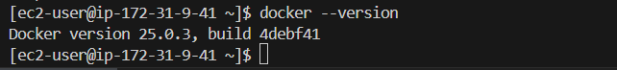

Check for the status of the service

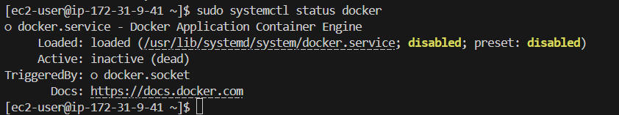

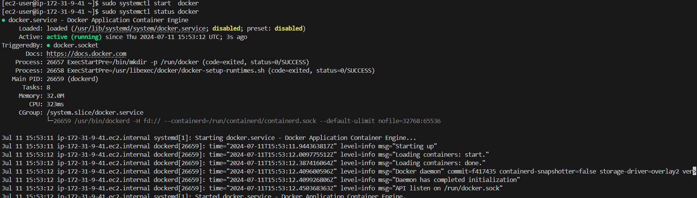

**Docker images**

1. List all images: **docker image ls**
2. Pull an image: **docker pull httpd:latest**
3. Tag an image: **docker tag httpd:latest webserver:latest**
4. Remove an image: **docker image rm webserver:latest**

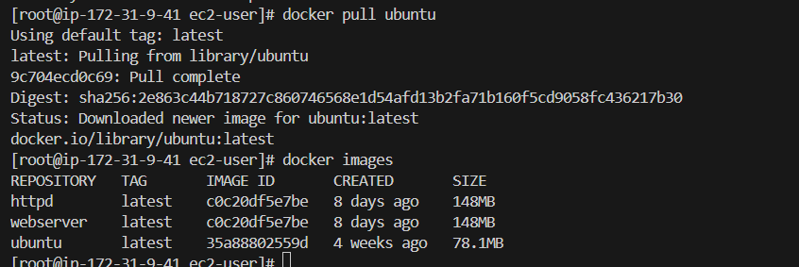

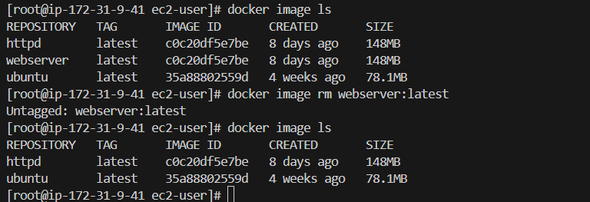

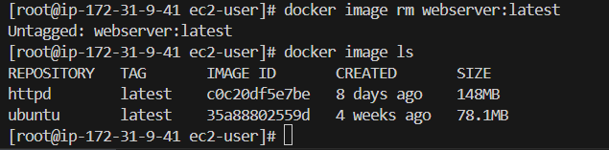s

**Docker Container:**

1. Run a container: **docker run –name web01 -p 75:80 -itd httpd**
2. List all container: **docker container ls**
3. Start a container: **docker start container name or container id**
4. Stop a container: **docker stop container name or container id**
5. Remove a container:

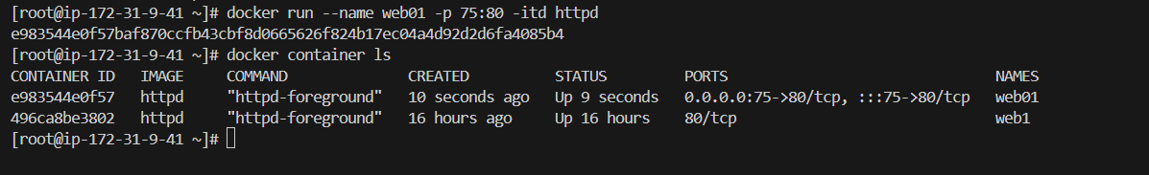

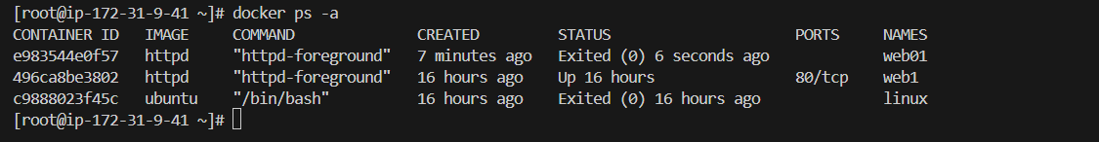



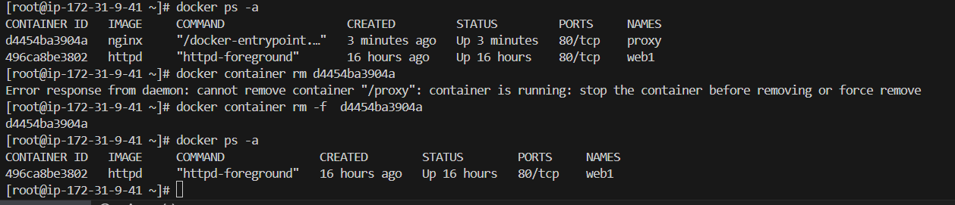

**Docker Volume commands:**

1. Create docker volume: **docker volume create <volume_name>**
2. Lists all volumes: **docker volume ls**
3. Removes a volume: **docker volume rm <volume_name>**
4. Removes all unused volumes: **docker volume prune**

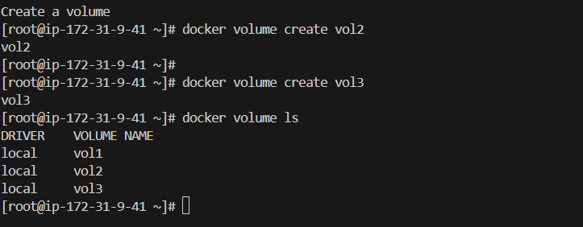

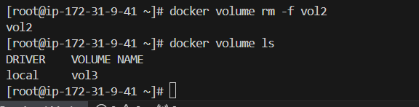

**Docker Network commands:**

1. Create docker network: **docker network create <network_name>**
2. Lists all networks: **docker network ls**
3. Removes a network: **docker network rm < network_name>**
4. Removes all unused network: **docker network prune**

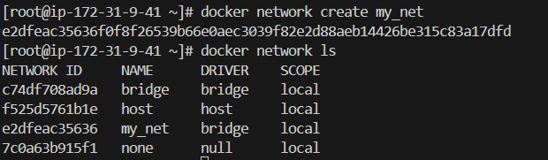

Connects a container to a network

